Military Community Programs
Toolkit

- Social Media Content
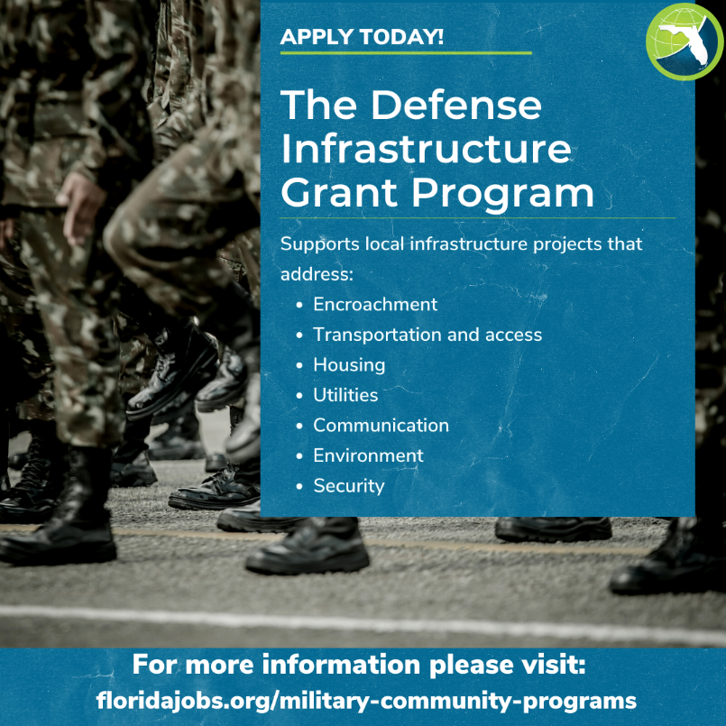
The application cycle is open for @FLDEO’s Defense Infrastructure Grant program to protect and support military installations and communities throughout the state. Learn more>> LINK

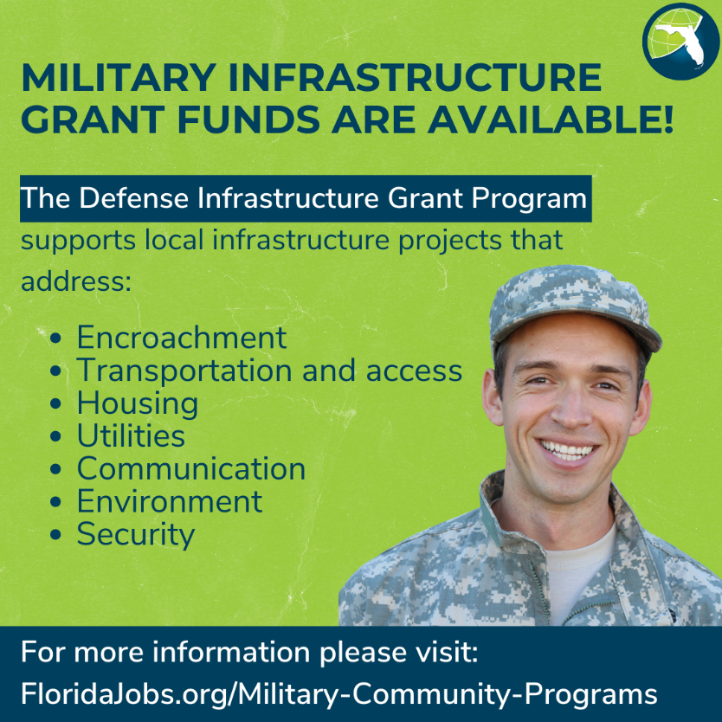
@FLDEO recently announced the application cycle for its Defense Infrastructure program to protect and support military installations and communities throughout the state. Learn more>>

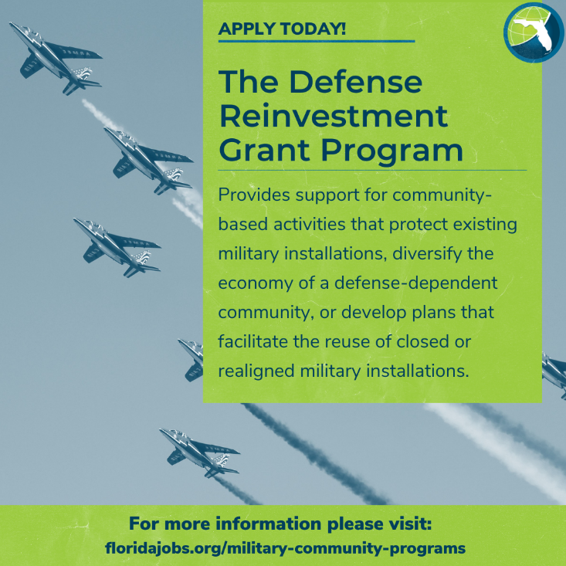
The application cycle is open for @FLDEO ’s Defense Reinvestment Grant program to protect and support military installations and communities throughout the state. Learn more>> LINK

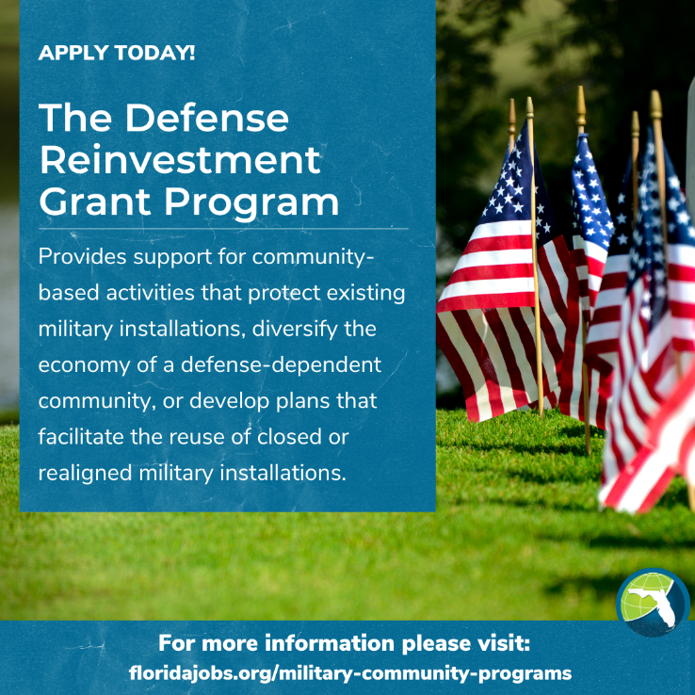
@FLDEO recently announced the application cycle for its Defense Reinvestment Grant program to protect and support military installations and communities throughout the state. Learn more>>
- Direct Communication

Subject Line: Military Community Funding Now Available through the Florida Department of Economic Opportunity

The Florida Department of Economic Opportunity recently announced that the application cycle is now open to apply for funding through the Defense Infrastructure Grant and Defense Reinvestment Grant programs. Applications will be accepted through Thursday, April 13, 2023, and additional information is available on the Military Community Programs webpage.

The Defense Infrastructure Grant Program (DIG) supports local infrastructure projects that make a positive impact on the military value of installations within the state by addressing encroachment, transportation and access, housing, utilities, communications, environment, and security needs. Funds are used for projects that benefit both local communities and military installations.

The Defense Reinvestment Grant Program (DRG) provides support for community-based activities that protect existing military installations, diversify the economy of a defense-dependent community, or develop plans that facilitate the reuse of closed or realigned military installations, such developing and implementing strategies that will help communities support the mission of military installations.

To learn more and apply, visit the Military Community Programs webpage.

- Leave Behind Flyer – See Attached

