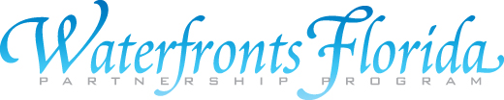

FLORIDA DEPARTMENT OF ECONOMIC OPPORTUNITY
DIVISION OF COMMUNITY DEVELOPMENT
Spring Program Meeting
May 24-25, 2012
Plantation Golf Resort & Spa
9301 W Fort Island Trail
Crystal River, FL 34429

DAY ONE: Thursday, May 24, 2012
Plantation Inn Conference Room

9:30 AM Registration and Welcome Mayor Jim Farley
Keith Shewbart, Chairman Crystal River Waterfronts Florida Partnership
Marla Chancey, Director of Tourism
Julie Dennis, DEO, DCD

10:00 AM Neighborhoods Protecting Water Quality: Audrey Durr, FL Yards and Homeowner-based Approaches Coordinator; Christina Collins,
SWFWMD; Jackie Gorman, Crystal River

11:00 AM Green Infrastructure in Coastal Communities Rosalyn Kilcollins, Apalachicola NERR

11:30 AM Conflict Resolution: Bruce Delaney, UF, NRLI
Resolving Community Disagreements

12:15 PM Nearby Lunch Options (Dutch Treat) – Handout provided at meeting
1:15 PM Guided Tour of Three Sisters Springs City of Crystal River & USFWS
Group will meet at City Hall for Tour

3: 00PM Reflections on a Multi-Year Local Revitalization City of Crystal River
Effort: Successes and Challenges in Crystal River

3:30 PM Community Roundtable Discussion Julie Dennis, DCD, DEO

Evening Activities

6:15 PM Group Networking Dinner at Plantation Inn (Dutch Treat)

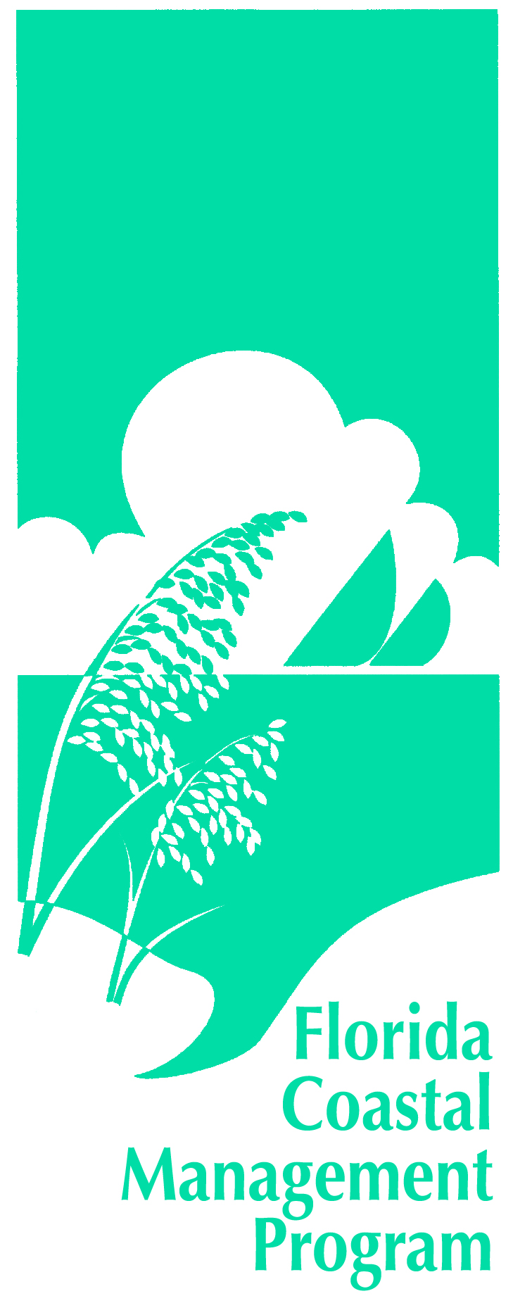
The Waterfronts Florida Program is managed by the Florida Department of Economic Opportunity and funded in part by the Florida Department of Environmental Protection, Florida Coastal Management Program, and the National Oceanic and Atmospheric Administration (NOAA).

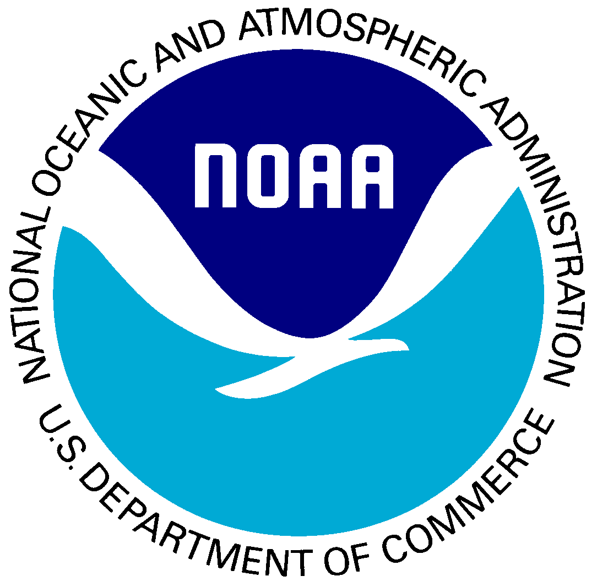
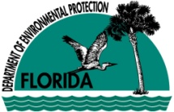

FLORIDA DEPARTMENT OF ECONOMIC OPPORTUNITY
DIVISION OF COMMUNITY DEVELOPMENT
Spring Program Meeting
May 24-25, 2012
Plantation Golf Resort & Spa
9301 W Fort Island Trail
Crystal River, FL 34429

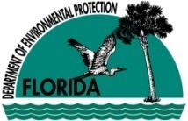
DAY TWO: Friday, May 25, 2012
The Waterfronts Florida Program is managed by the Florida Department of Economic Opportunity and funded in part by the Florida Department of Environmental Protection, Florida Coastal Management Program, and the National Oceanic and Atmospheric Administration (NOAA).

8:15 AM Welcome, Registration, and Door Prizes! Julie Dennis, DCD, DEO
Crystal River Waterfronts

8:30 AM One Rake at a Time Program Art Jones, Kings Bay Rotary Club

9:00 AM Kings Bay Tour Jackie Gorman, Crystal River

10:15 AM Networking Break

10:30 AM Derelict Vessel Removal: Local Programs Phil Horning,
and Grant Opportunities Captain Richard Moore, Lieutenant John Jones, Captain John Burton, Officer Kam Johnson, Lieutenant Darrin Riley, Captain Roy Brown

11:15 AM FWC Mooring Pilot Project and Major Jack Daugherty, Section Boating and Waterways Section Update Leader, Boating & Waterways, FWCC

11:45 AM Coastal Wildlife Conservation Initiative Blair Hayman, FWC

12:15 PM Wrap-up and Adjourn Julie Dennis, DCD, DEO

The Waterfronts Florida Program is managed by the Florida Department of Economic Opportunity and funded in part by the Florida Department of Environmental Protection, Florida Coastal Management Program, and the National Oceanic and Atmospheric Administration (NOAA).

