Background

The Capital Project Fund Multi-Purpose Community Facility Projects Program is designed to expand broadband access, prioritizing unserved and underserved Florida communities with limited broadband Internet service and with demonstrated economic distress factors.

The program helps communities create public locations for Floridians to access digital workforce, education and healthcare opportunities. Eligible applicants include school districts, state colleges, state universities, county governments, municipalities, identifiable census-designated communities, non-profits, or private entities, such as Internet Service Providers.

The application cycle for the program closes on Thursday, October 16, 2023 at 5pm Eastern Time.

This following material is proposed to market the program with the goal of increasing the engagement of potential applicants.

Objectives
- Targeted Email to institutions and facilities
- Social Media Content
- Newsletter Article
- Flyer

- Targeted Communication

  - Email to institutions and facilities

Subject: Apply Now! Multi-Purpose Community Facility Projects Program

Body:
Good morning/afternoon,

The FloridaCommerce Office of Broadband is currently accepting applications for the Capital Projects Fund – Multipurpose Community Facility Projects Fund (MPCF).

Eligible applicants can apply to receive funds for the construction of or improvements to buildings designed to enable access to digital workforce, education, and healthcare opportunities, located in communities with a critical need.

Eligible applicants include:
- Local governmental units (e.g., municipalities or counties)
- Non-profit organizations
- Private entities which can be in the form of corporations, limited liability companies, general partnerships or limited partnerships
- Internet Service Providers, broadband Internet training institutions and information technology programs
- Libraries, healthcare facilities, law enforcement academies and other community anchor institutions
- Higher education institutions (e.g., universities, community colleges or technical colleges)
- Nursing and critical health profession programs
- Multi-purpose community centers
- Co-operatives and electric utilities

FloridaCommerce hosted a webinar on August 16, 2023, to provide potential applicants with information about the MPCF program. To view the webinar, and for more information about the program, please visit FloridaJobs.org/Broadband.

The current application cycle closes on Thursday, October 16, 2023 at 5pm Eastern Time. Applicants are encouraged to apply through the Broadband Application Portal.

Please reach out to the FloridaCommerce Office of Broadband at Broadband@Commerce.fl.gov with any questions.

- Newsletter Article

Funding Available: Multi-purpose Community Facility Projects Fund Now Accepting Applications

The FloridaCommerce Office of Broadband is currently accepting applications for the Capital Projects Fund – Multi-purpose Community Facility Projects (MPCF) program. The program is designed to expand broadband access, prioritizing unserved and underserved Florida communities with limited broadband internet service and with demonstrated economic distress factors.

Internet connectivity has become foundational for most activities of modern life and connects Floridians with widespread opportunity. Unfortunately, many Floridians still lack access to reliable high-speed Internet services. Broadband technology significantly improves internet connectivity and presents an opportunity for Florida's small and rural communities to achieve transformational growth, driven by increased digital literacy, a highly skilled workforce, high-demand employment prospects, and the availability of site-ready infrastructure. This growth will benefit local communities for years to come.

The MPCF program provides funds to eligible applicants for the construction of or improvements to buildings designed to enable access to digital workforce, education, and healthcare opportunities, located in communities with a critical need.

Eligible applicants include:
- Local governmental units (e.g., municipalities or counties)
- Non-profit organizations
- Private entities which can be in the form of corporations, limited liability companies, general partnerships or limited partnerships
- Internet Service Providers, broadband Internet training institutions and information technology programs
- Libraries, healthcare facilities, law enforcement academies and other community anchor institutions
- Higher education institutions (e.g., universities, community colleges or technical colleges)
- Nursing and critical health profession programs
- Multi-purpose community centers
- Co-operatives and electric utilities

The application deadline is October 16, 2023.

For more information and to apply, visit FloridaJobs.org/Broadband.

- Social Media Content

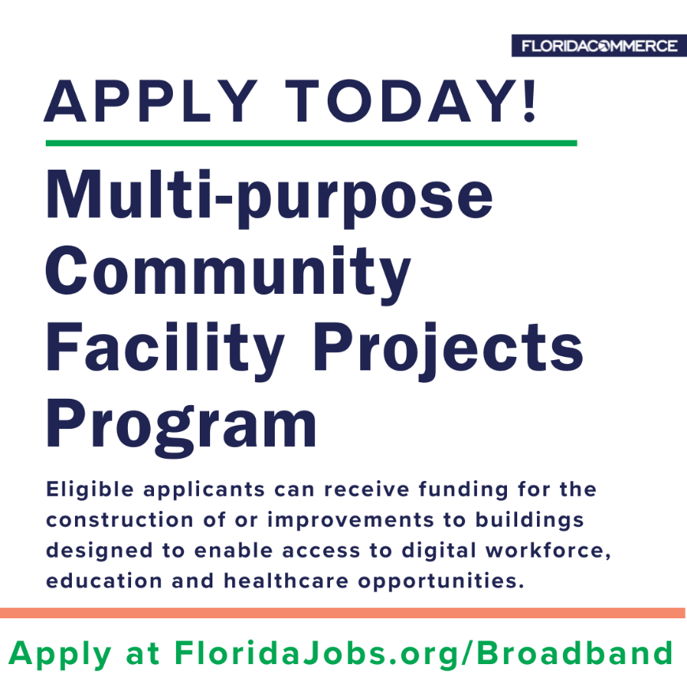
The @FLACommerce Multi-Purpose Community Facility Program is now accepting applications. Eligible applicants can receive funding for public locations for Floridians to access digital workforce, healthcare and education opportunities.

Apply today at FloridaJobs.org/Broadband

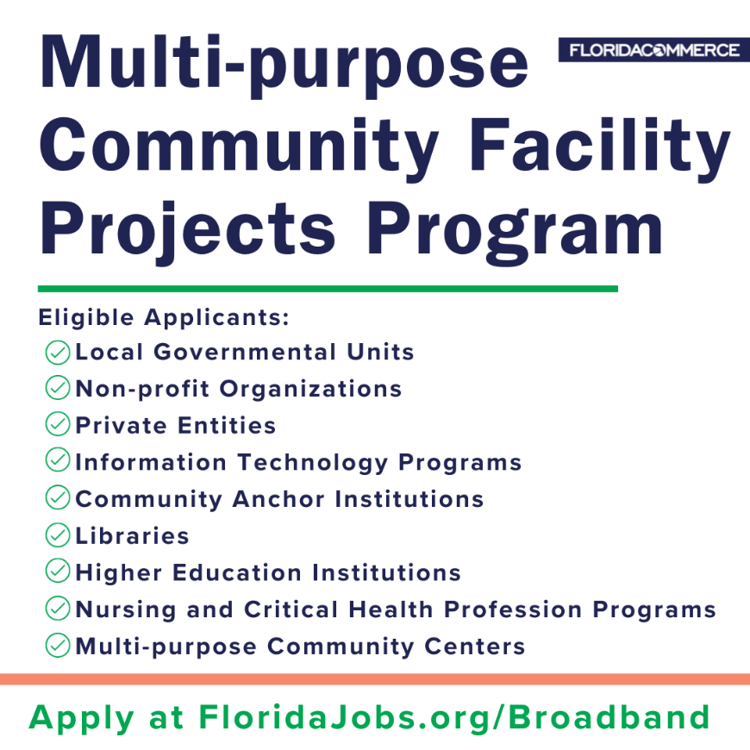
DEADLINE APPROACHING!

Funding is available for the construction of or improvement to public locations for Floridians to access digital workforce, healthcare and education opportunities. Apply before October 16, 2023, 5pm EST at FloridaJobs.org/Broadband.

- Flyer – Attached

